34.11: a)

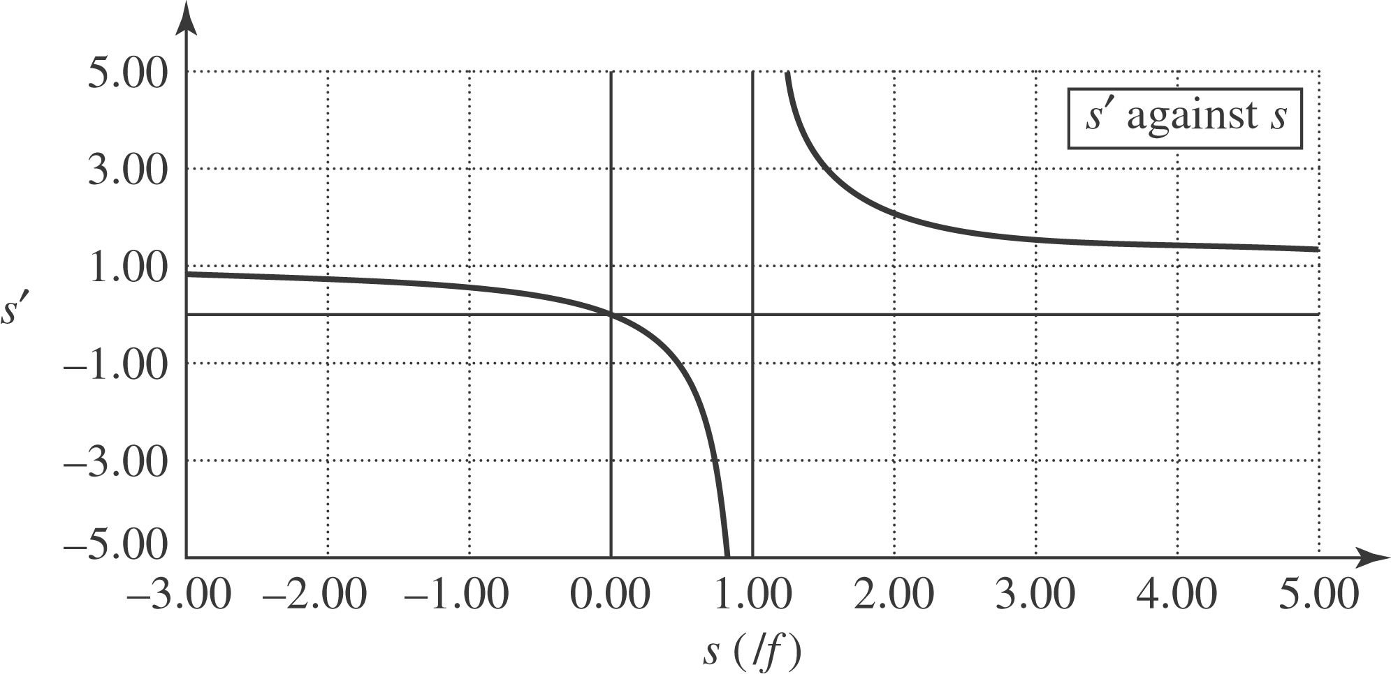

b) 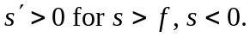
c) 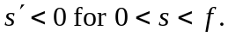
d) If the object is just outside the focal point, then the image position approaches positive infinity.
e) If the object is just inside the focal point, the image is at negative infinity, “behind” the mirror.
f) If the object is at infinity, then the image is at the focal point.
g) If the object is next to the mirror, then the image is also at the mirror.
h)

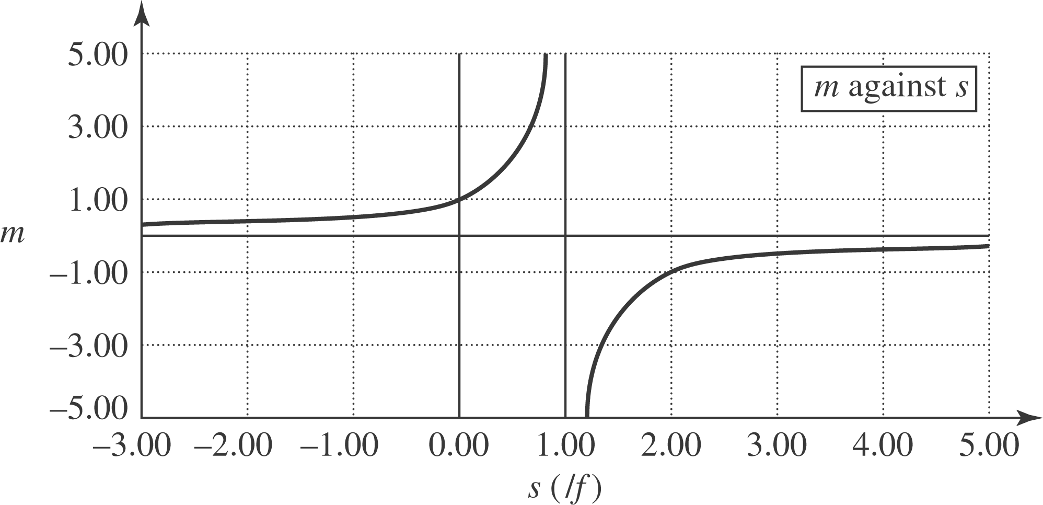

i) The image is erect if 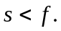
j) The image is inverted if 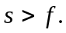
k) The image is larger if 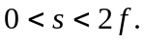
l) The image is smaller if 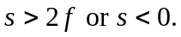
m) As the object is moved closer and closer to the focal point, the magnification INCREASES to infinite values.

